Name: Water Study Guide

Be able to explain why water is so important. The more details the better.

What are the 3 states of matter that water can be in?

What percentage of the Earth’s water is fresh water? Salt water?

Be able to DRAW, LABEL, AND EXPLAIN the 5 main parts of the water cycle.

Evaporation –

Transpiration –

Condensation –

Precipitation –

Infiltration –

Runoff –

What percentage or fraction of the Earth’s surface is covered by water?

What are examples of surface water?

Where is most of Earth’s fresh water found?

What is a water molecule made of?

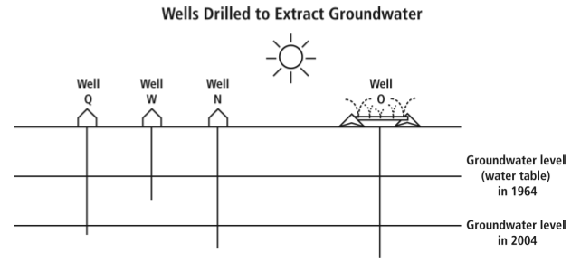

Be able to understand and explain what the diagram is showing you.

Which well is used for farming?

Which wells are for residential (housing)?

Be able to explain why the water levels are going down.

About how many people on Earth do not have access to safe drinking water?

Who is most affected by the diseases and parasites in unclean drinking water?

What does potable mean?

