Name: Water/Atmosphere Study Guide

1. Be able to explain why our atmosphere is so important. The more details the better.

2. What is the Earth’s atmosphere made of?

3. Where is the Earth’s atmosphere most dense and least dense?

4. What does the ozone layer do?

5. What are the 4 main layers of the atmosphere? Write one important fact about each layer.

16. Be able to read and understand the following graph.
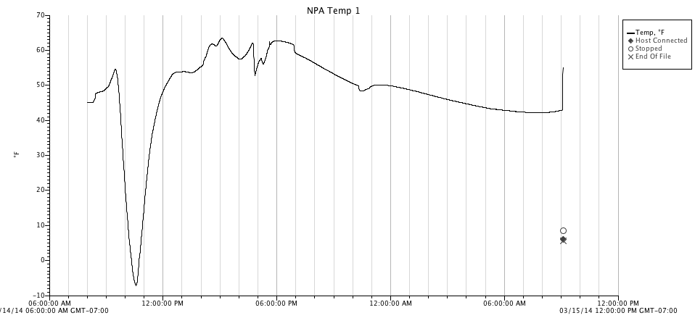

17. Be able to explain how temperature and radiation changes as you go higher up in the atmosphere. Use your balloon data graphs as part of your study guide. Be able to explain why temperature and pressure change throughout the atmosphere.

Be able to draw and explain a Geostationary Operational Environmental Satellite. Where is it and what is its main function?

Be able to draw and explain a Polar Operational Environmental Satellite. Where is it and what is its main function?

What is a barometer and what does it tell us?

What is a thermometer and what does it tell us?

What is an anemometer and what does it tell us?

What is a meteorologist? Where do they get the information to make weather predictions?

What is the difference between a high and low pressure system?

What are at least 3 different weather related natural disasters?

Be able to read and interpret a weather map. Know about the different fronts, high and low pressure.
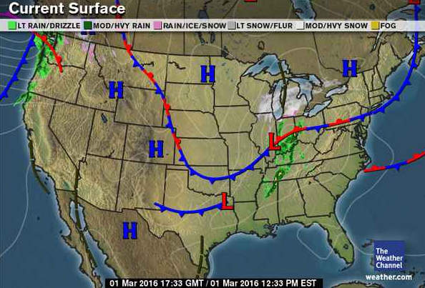

Be able to convert Fahrenheit to Celsius and vice versa.

100 degrees Fahrenheit equals how many degrees Celsius?

42 degrees Celsius equals how many degrees Fahrenheit?

