Metric Study Guide

Measure the following lines in centimeters. Don’t forget your units.

1. ________________________________________________________ _____________

2. ___________________ _____________

3. ____________________________________ _____________

4. _________________________________________________ _____________

How many milliliters are in the graduated cylinders?

5. 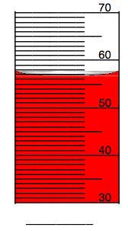 6. 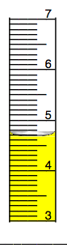 7. 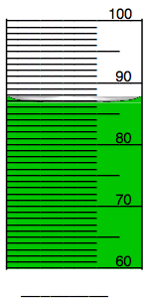

Volume – Don’t forget your units!
9. A graduated cylinder read 20mL. You put a marble in the cylinder and the water rises to 23mL. What is the volume of marble?

_______________________
8. A box is 20cm long, 3 cm wide,
and 10 cm high. What is the volume
of the box?

_____________________

10. What is the volume of the box if it is 5cm high, 2 cm long and 3 cm wide?

_____________________

11. What are the three base units of measurement in Metrics?

12. What do the six prefixes mean?

-
-
-
-
-
-

13. What do you use to measure length?

14. What do you use to measure mass?

15. What do you use to measure liquids?

16. What do you look for when reading a liquid measurement?

17. What is the difference between mass and weight?

18. What is volume?

19. How does mass impact the launch of a rocket trying to leave Earth’s gravitational pull? Use Newton’s laws of motion to help you explain it.

20. What would happen to your mass and weight if you went to the moon?

Convert – Show your work below.

21. 90 M = ___________________ mm
22. 60 dm = ___________________ Dm
23. 40 Hm = ___________________cm
24. 34 dm = ___________________ cm
25. 4.5 cm = ___________________ M
26. 360 mm = ___________________Km

