Name_______________

Cell Project
Purpose: The purpose of this project is to make a 3D model of a cell in order to better understand the parts and workings of a cell.
Using household items make a three-dimensional model of a plant or animal cell that meets the criteria listed below. (Sample items: cereal, balloons, gummi worms, mints, fruit slices, dried fruit, matches, gum balls, peanuts, rope licorice, jelly beans, sesame seeds, other candies, toothpicks. Craft packages also may work: clay, beads, pipe cleaners..etc)
Choose what type of cell you will build, a typical plant or animal cell. Include this label somewhere on your model.

Cell Project Rubric
Category | Scoring Criteria | Excellent (5 pts) | Satisfactory (3 pts) | Minimal (1 pt)
Craftsmanship | Model is creative, shows effort
 | The model is 3 dimensional
 | Model stays together, not too messy or difficult to move around
Cell Parts | Key, legend, or labeling is easy to use to identify parts on the model
 | Functions of cell parts included (accurate)
 | Appropriate material is used so that it looks like the cell part it is modeling
 | Parts of organized within the cell in their appropriate places
Written Word | Basic grammar, spelling on key and any other writing used in model

Create a KEY or label in some way each part on your model and its function.

Samples:
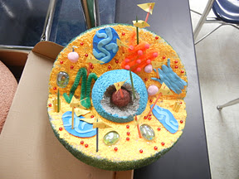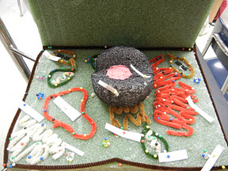

Write a summary to go along with your model describing what kind of cell you made, the cell parts, and the organelle functions. This can be what you share with the class. 10 points!

